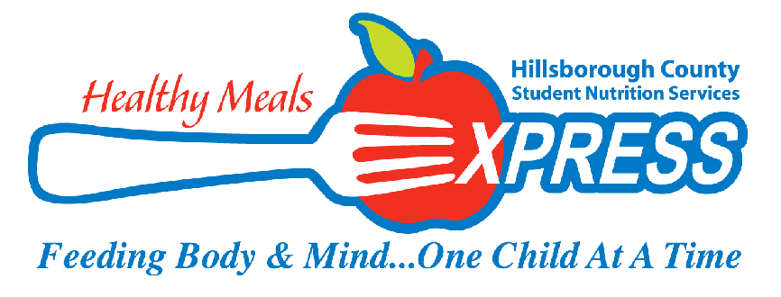
HILLSBOROUGH COUNTY PUBLIC SCHOOLS
STUDENT NUTRITION SERVICES STUDENT FALL READY TO SERVE MASTER MENU
August
MONDAY | TUESDAY | WEDNESDAY | THURSDAY | FRIDAY
 | 8/10 Breakfast  Apple Cinnamon Chewy Bar  100% Juice  White Milk (Low Fat or Fat Free)  Lunch  Cuban Sandwich  Veggie Dippers w/ Ranch  Raisins  Assorted Low Fat Milk  High School-ONLY-  Offer juice as second fruit  at lunch | 8/11 Breakfast  Eggo® Mini Blueberry Pancakes  100% Juice  White Milk (Low Fat or Fat Free)  Lunch  BBQ Chicken Sandwich  BBQ Baked Beans  Fresh Apple Slices  Assorted Low Fat Milk  High School-ONLY  Offer juice as second fruit  at lunch | 8/12 Breakfast  Yogurt Fruit Smoothie w/ Graham  100% Juice  White Milk (Low Fat or Fat Free)  Lunch  Tuscan Chicken Alfredo  Steamed Broccoli  Apple Crisps  Assorted Low Fat Milk  High School-ONLY  Offer juice as second fruit  at lunch  and mini roll at lunch | 8/13 Breakfast  Banana Chocolate Chunk Protein Bar  100% Juice  White Milk (Low Fat or Fat Free)  Lunch  Baked Ziti  Cucumbers with Ranch  Fresh Orange Smiles  Assorted Low Fat Milk  High School-ONLY  Offer juice as second fruit  At lunch and Mini Roll at Lunch
8/16 Breakfast  Cereal w/ Graham  100% Juice  White Milk (Low Fat or Fat Free)  Lunch  Tuscan Rotini & Meatballs  Celery with Ranch  Applesauce Fruit cup  Assorted Low Fat Milk  High School ONLY  Offer juice as second fruit at lunch | 8/17 Breakfast  Apple Cinnamon Chewy Bar  100% Juice  White Milk (Low Fat or Fat Free)  Lunch  TACO TUESDAY  Santa Fe Beef Tacos  Seasoned Black Beans  Fruit Cup  Assorted Low Fat Milk  High School ONLY  Offer Juice as second fruit  At lunch | 8/18 Breakfast  Eggo® Mini Cinnamon Waffles  100% Juice  White Milk (Low Fat or Fat Free)  Lunch  Teriyaki Chicken w/ Fried Rice  Fresh Veggie Dippers  Peach Slices  Assorted Low Fat Milk  High School ONLY  Offer juice as second fruit  At lunch | 8/19 Breakfast  Yogurt Smoothie w/ Graham  100% Juice  White Milk (Low Fat or Fat Free)  Lunch  Mac n Cheese  Crisp Garden Side Salad  Fresh Apple Slices  Assorted Low Fat Milk  High School ONLY  Offer juice as second fruit  At lunch | 8/20 Breakfast  Banana Chocolate Chunk Protein Bar  100% Juice  White Milk (Low Fat or Fat Free)  Lunch  Turkey & Swiss Croissant Carrots with Ranch  Applesauce fruit cup  Assorted Low Fat Milk  High School-ONLY  Offer juice as second fruit  At lunch
8/23 Breakfast  Cereal w/ Graham  100% Juice  White Milk (Low Fat or Fat Free)  Lunch  Meatball Marinara Sub  Sweet Kernel Corn  Assorted Fruit Cups  Assorted Low Fat Milk  High School ONLY  Offer juice as second fruit  at lunch | 8/24 Breakfast  Apple Cinnamon Chewy Bar  100% Juice  White Milk (Low Fat or Fat Free)  Lunch  TACO TUESDAY  Baja Carnitas Tacos  Herbed Green Beans  Peach Slices  Assorted Low Fat Milk  High School ONLY  Offer juice as second fruit  At lunch | 8/25 Breakfast  Eggo® Mini Blueberry Pancakes  100% Juice  White Milk (Low Fat or Fat Free)  Lunch  Chicken & Yellow Rice  Seasoned Black beans  Applesauce  Assorted Low Fat Milk  High School ONLY  Offer juice as second fruit  At lunch | 8/26 Breakfast  Yogurt Smoothie w/ Graham  100% Juice  White Milk (Low Fat or Fat Free)  Lunch  Ham & Cheese Croissant  Veggie Dippers w/ ranch  Apple Crisps  Assorted Low Fat Milk  High School ONLY  Offer juice as second fruit at lunch | 8/27 Breakfast  Banana Chocolate Chunk Protein Bar  100% Juice  White Milk (Low Fat or Fat Free)  Lunch  Popcorn Chicken  Cheez its  Steamed Broccoli  Assorted Fruit cups  Assorted Low Fat Milk  High School ONLY  Offer juice as second fruit  at lunch
8/30 Breakfast 8/31 Breakfast

High School is to serve another serving of fresh fruit daily at Lunch-See note on each day’s lunch menu.

* Indicates a vegetarian meal item. Revised 5/20/21

